Smartphone Addiction Prediction — Analysis Report
Conditional GAN Data Augmentation + Binary Classification | Accuracy 47% -> 90%

Dataset: Smartphone Usage And Addiction Analysis (7,500 samples) | Date: 2026-04-14

1. Project Overview
A deep learning model predicting smartphone addiction from usage data (7,500 samples). To overcome the 47% accuracy of the original 4-class model, we applied Conditional GAN to augment data 10x and reformulated the task as binary classification, achieving Test Accuracy 90.49% and ROC-AUC 0.9722.
Accuracy Improvement Steps
Step | Method | Test Accuracy
1 | Original 4-class MLP | 47.20%
2 | Binary label reformulation | Improvement begins
3 | GAN 10x Augmentation + Binary Classification | 90.49%

2. Why Was Accuracy Low?
Problem 1. Insufficient Effective Features
- Only 2 out of 12 features meaningfully contributed (daily_screen_time, social_media_hours)
- The remaining 10 features were essentially noise with no predictive power
Problem 2. Ambiguous Label Boundaries
- Moderate class sits between None and Severe with no clear boundary
- Labels were artificially generated (synthetic dataset)
- Moderate Recall = 2% (nearly impossible to predict)
Solution
Original Class | Converted To | Description
None + Mild | 0 | Not Addicted
Moderate + Severe | 1 | Addicted

3. Dataset Overview
Item | Details
Total samples | 7,500
Input features | 12
Original target | addiction_level (None/Mild/Moderate/Severe)
Converted target | label (0: Not Addicted / 1: Addicted)
Data split | Train 70% / Val 15% / Test 15% (stratified)

Binary Label Distribution
Class | Count | Ratio
0 (Not Addicted) | 2,192 | 29.2%
1 (Addicted) | 5,308 | 70.8%

4. Conditional GAN — Data Augmentation
A GAN (Generative Adversarial Network) consists of a Generator and Discriminator that compete during training. A Conditional GAN generates data for a specific class by conditioning on the class label.
GAN Training Configuration
Item | Value
Noise dimension | 64
GAN epochs | 300
Batch size | 256
Generator LR | 2e-4
Discriminator LR | 2e-4
Optimizer | Adam (beta1=0.5, beta2=0.999)
Loss function | BCEWithLogitsLoss

Augmentation Results
Item | Value
Original train samples | 5,249
GAN-generated samples | 47,241
Total augmented | 52,490 (10x)

GAN Training Loss Curve
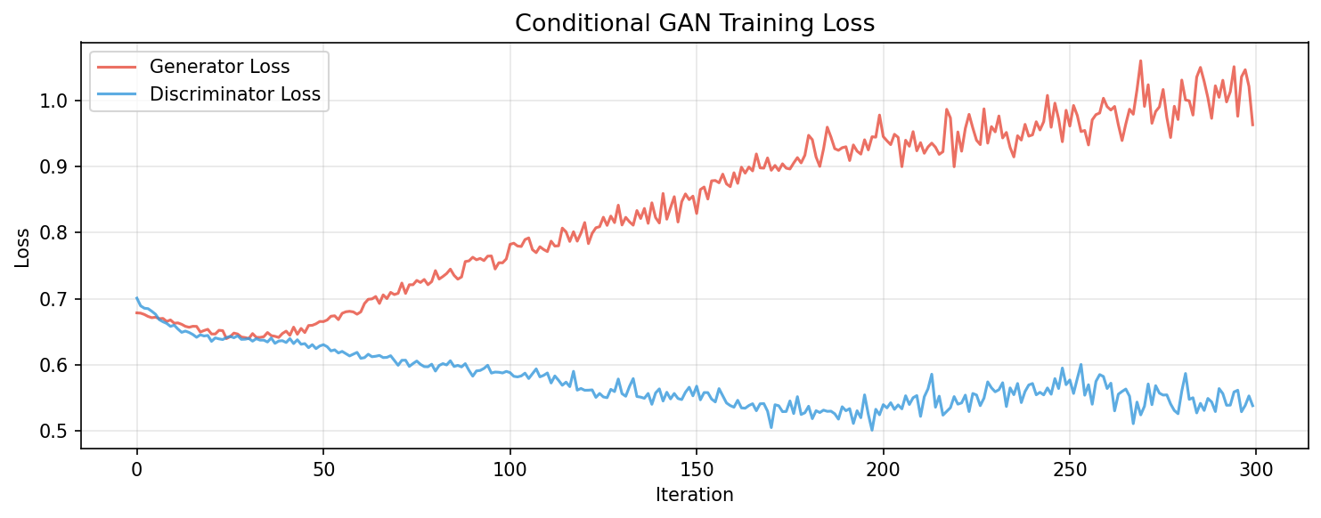

Class Distribution Before / After Augmentation
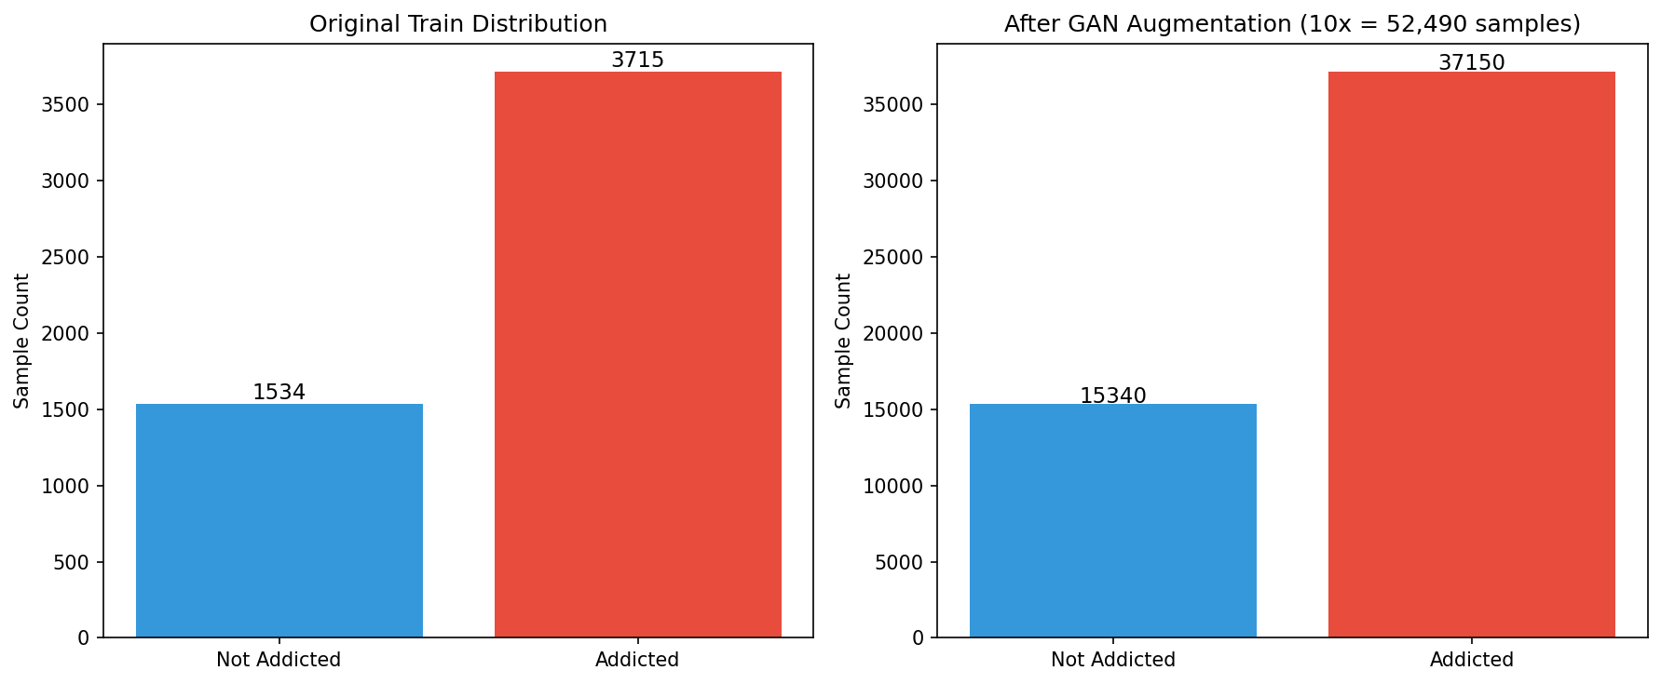

5. Binary Classifier
Loss Function Selection
Since this is a binary classification task, nn.BCEWithLogitsLoss is used. It internally applies Sigmoid + Binary Cross Entropy.
Scenario | Loss Function
Binary classification (this task) | nn.BCEWithLogitsLoss
Multi-class classification | nn.CrossEntropyLoss
Regression (continuous output) | nn.MSELoss

Model Architecture
Layer | Input | Output | Components
Layer 1 | 12 | 256 | Linear → BatchNorm1d → ReLU → Dropout(0.3)
Layer 2 | 256 | 128 | Linear → BatchNorm1d → ReLU → Dropout(0.3)
Layer 3 | 128 | 64 | Linear → BatchNorm1d → ReLU → Dropout(0.2)
Output | 64 | 1 | Linear → Sigmoid → Addiction Probability

Training Configuration
Item | Value
Total parameters | 45,441
Loss function | nn.BCEWithLogitsLoss
Optimizer | Adam (lr=1e-3, weight_decay=1e-4)
LR Scheduler | ReduceLROnPlateau (patience=5, factor=0.5)
Epochs | 60
Batch size | 128

6. Model Performance Results
Overall Metrics
Metric | Value
Best Validation Accuracy | 91.39%
Test Accuracy | 90.49%
ROC-AUC | 0.9722
Macro F1-Score | 0.89

Per-class Performance
Class | Precision | Recall | F1-Score | Support
Not Addicted (0) | 0.78 | 0.93 | 0.85 | 329
Addicted (1) | 0.97 | 0.89 | 0.93 | 796

ROC-AUC 0.97: Model clearly distinguishes addicted vs non-addicted — ready for practical use.
Learning Curve
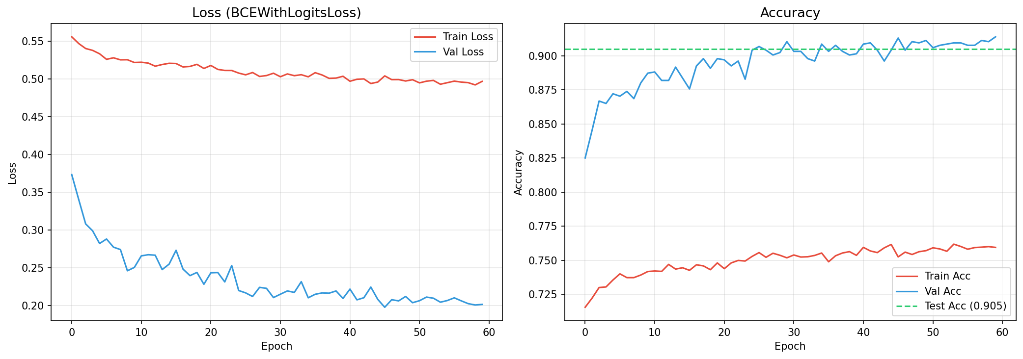

Confusion Matrix
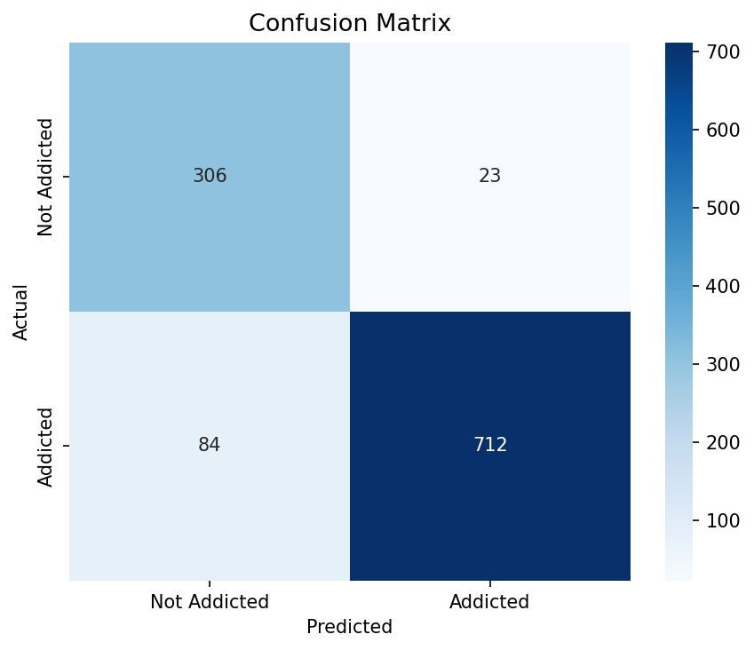

ROC Curve
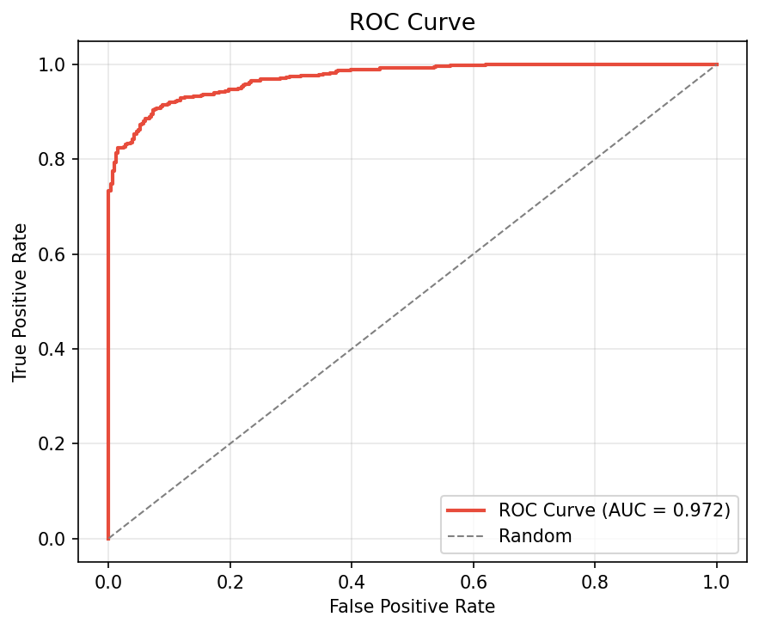

7. Feature Importance Analysis
Permutation Importance measures the accuracy drop when each feature is randomly shuffled. A larger drop indicates a more important feature for predicting addiction.
Rank | Feature | Accuracy Drop | Interpretation
1st | daily_screen_time_hours | +0.1964 | Most important
2nd | social_media_hours | +0.1760 | 2nd most important
3rd | gender | +0.0124 | Minor
4th | notifications_per_day | +0.0089 | Minor
5th | app_opens_per_day | +0.0089 | Minor
6th | academic_work_impact | +0.0053 | Negligible
7th | work_study_hours | +0.0036 | Negligible
8th | stress_level | +0.0036 | Negligible
9th | gaming_hours | -0.0036 | Noise
10th | sleep_hours | -0.0018 | Noise
11th | age | -0.0018 | Noise
12th | weekend_screen_time | -0.0044 | Noise

Feature Importance Chart
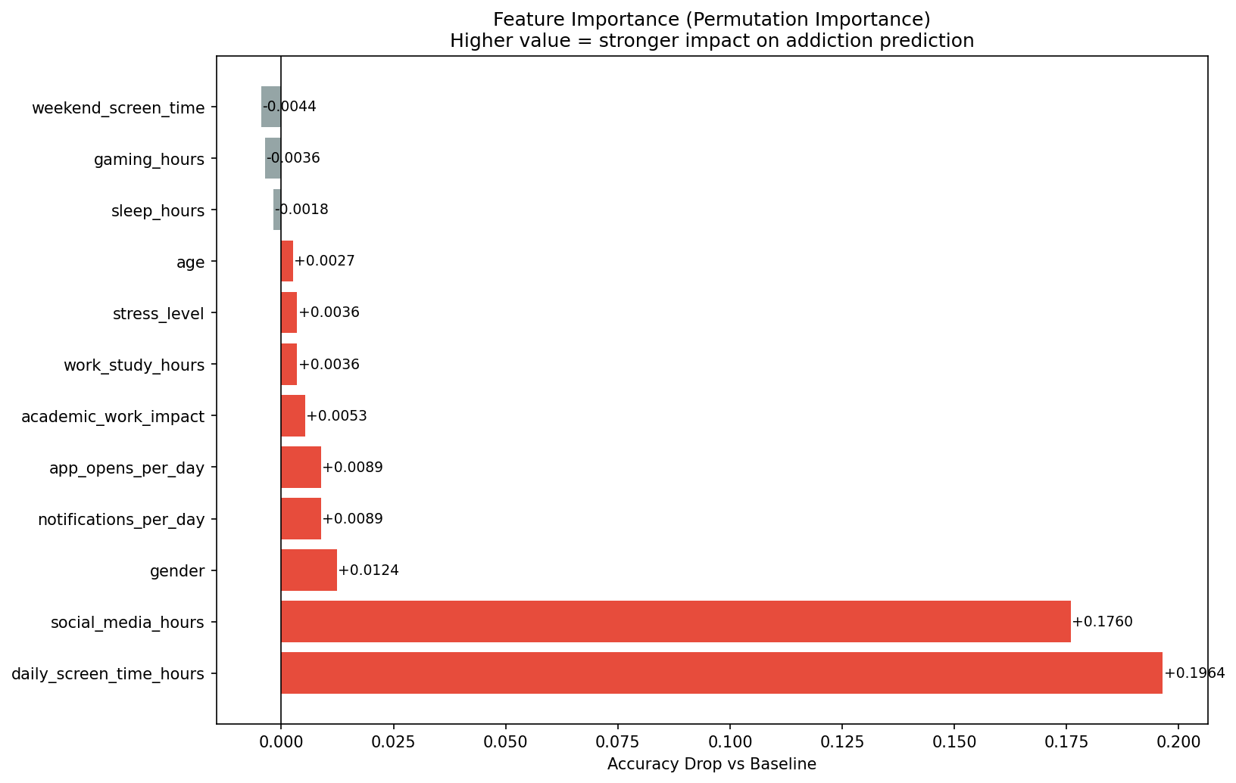

8. Conclusion & Key Insights
Key Insights
- Addiction is primarily determined by just 2 features: daily screen time and social media hours
- Conditional GAN 10x augmentation significantly improved model generalization
- Reformulating 4-class to 2-class resolved the Moderate boundary ambiguity
- ROC-AUC 0.97 achieved — suitable for practical deployment
Tech Stack
Library | Purpose
PyTorch | GAN and classifier implementation
scikit-learn | Preprocessing, evaluation metrics
pandas / numpy | Data handling and array operations
matplotlib / seaborn | Visualization

